Methodology:
9 | Biblical Interpretation and the Biblical Canon

Agenda: Considering principles of interpretation (hermeneutics) related to and informed by the context of the entirety of scripture.

I. The unity of Biblical revelation. Cf. Inerrancy; inspiration.

- In terms of truth-claims.

- In terms of metanarrative.

* This unity does not preclude diversity.

II. Regula Fidei (or “analogy of faith”).

Interpret scripture with scripture. Understand more obscure or difficult passages in light of clearer passages.

* Implication – Don’t base doctrines entirely on obscure or difficult passages. Base doctrines most centrally on clear passages that address such doctrinal matters.

III. The significance of Biblical corpuses, e.g., Paul’s letters.

Cf. Inspiration – Divine (thus unity) and human (thus diversity) authorship.
* Theologies within one coherent theology.
* Recognizing diversity.

- Interpreting a Biblical author in light of that author’s corpus.

Seek to understand the author in light of what they say elsewhere.

For example:
- Language (e.g., Paul’s use of “calling” v. Luke’s).
- Theological concepts (e.g., John’s emphasis on eternal life; light and darkness motifs, etc.).

- The relationship between Biblical corpuses.

Let particular texts and authors speak on their own terms with their own emphases and own particularities.
- Don’t mute their voice with another corpus.
- Regula fidei doesn’t mean or appealing to another passage when we don’t like or struggle with a text.
- Not “canon with a canon.”

* A check, a guard – Given the unity of scripture, you will know you have erred if you interpretation leads to a conflict with another text. In this case, you’ve interpreted one or both passages incorrectly.

- Parallels – Their abuse and proper use.

* Scripture’s unity (divine authorship) pushes us to seek parallels. But be sensitive to diversity (various human authors).

IV. Understanding the Bible in light of canonical context.

- Considering location within redemptive history.

  - Considering the metanarrative –Where am I in the story?

  - Considering progressive revelation – How much is known at this point? (Cf. complementary hermeneutics.)

  - Considering issues of continuity and discontinuity – What is different or the same?

Examples:
- Holy Spirit’s indwelling presence.
- The Mosaic Law.
- People of God.

- Reading the entirety scripture in light of the centrality of Christ.
PowerPoint.

Luke 24:25-27 – ²⁵ And He said to them, “O foolish men and slow of heart to believe in all that the prophets have spoken! ²⁶ “Was it not necessary for the Christ to suffer these things and to enter into His glory?” ²⁷ Then beginning with Moses and with all the prophets, He explained to them the things concerning Himself in all the Scriptures.

“Every passage of Scripture–in both the Old and New Testaments–either predicts, prepares for, reflects, or results from the work of Christ.” – C.J. Mahaney.

- Considering the New Testament’s logical priority over the Old Testament.

- Understanding the Old Testament in light of its climax in Christ.

Appendix C; PowerPoint.
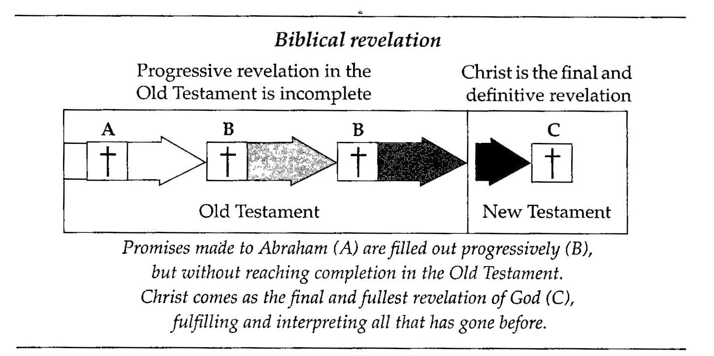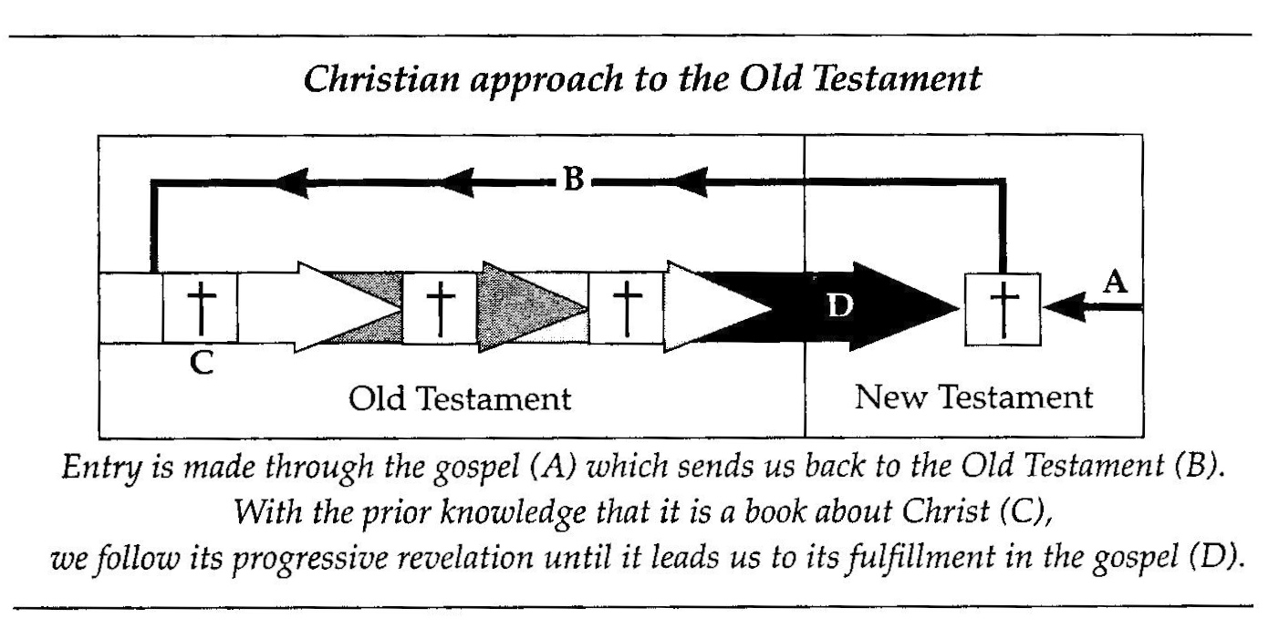

“Because the New Testament declares the Old Testament to be incomplete without Christ we must understand the Old Testament in the light of its goal which is Christ. Jesus is indispensable to a true understanding of the Old Testament as well as the New.”

- Understanding the New Testament in light of the Old Testament.

- With regards to themes, e.g., sacrifice, temple, holiness, kingship, etc.

- With regards to metanarrative – The fulfillment of the New Testament will correspond to the anticipation of the Old Testament.

- Considering the “Already/Not Yet” framework of fulfillment (realization) of eschatological realities.
Appendix C; PowerPoint.
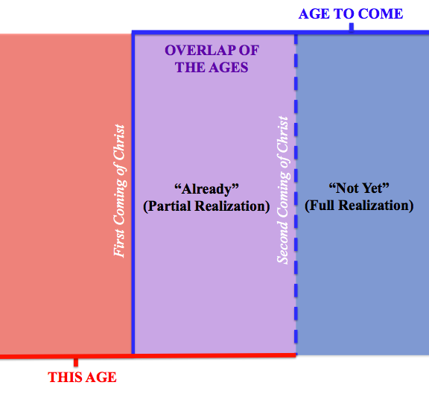

- Cf. Old Testament’s anticipation of instantaneous arrival of eschatological realities v. New Testament’s presentation of two comings of Christ and eschatological realities arriving in two stages.

- Interpretive significance – This framework helps one sort out passages that relate to the fulfillment of God’s promises or the outworking of God’s plan of salvation.

These two diagrams are from Graeme Goldsworthy, According to Plan.
. Graeme Goldsworthy, Gospel and Kingdom (Crownhill, Milton Keynes: Paternoster, 2012), 49.

